1. Backlog
1.1 Iteration 1: Core Security Engine (Days 1–7)
•Goal: Intercept DSH tool calls and block unauthorized commands using a default-deny whitelist without crashing DSH.
ID | Item | Priority | Estimate | Testable Acceptance Criteria | Assignee
PB-01 | Tool Interception Hook | P0 (Must) | 3d | Given an agent calls run_command,  When DSH processes the call,  Then the plugin intercepts it before execution and returns an allow or deny result. | Liu Jiazhuang (Dev)
PB-02 | Target Blacklist & Self-Protection | P1 (Should) | 2d | Given a blacklist protecting plugin.config.json by default plus custom forbidden targets,  When an agent tries to access or modify a blacklisted target,  Then the plugin immediately blocks it. | Liu Jiazhuang (Dev)
1.2 Iteration 2: Web GUI & System Hardening (Days 8–14)
•Goal: Add a visual configuration UI in DSH and verify that tool limits cannot be bypassed by an autonomous agent.
ID | Item | Priority | Estimate | Testable Acceptance Criteria | Assignee
PB-04 | Web GUI Integration | P0 (Must) | 3d | Given the user opens DSH in a browser,  When clicking the tool limitation plugin tab,  Then a settings panel renders correctly. | Zhang Bochen (UI)
PB-05 | Rule Editor & Reloading | P0 (Must) | 2d | Given the user adds a new whitelist rule in the GUI,  When clicking "Save",  Then the rule saves to disk and takes effect immediately without restarting DSH. | Zhang Bochen (UI)
PB-07 | User Documentation & Guide | P1 (Should) | 2d | Given a new user installing the plugin,  When following the setup guide,  Then they can successfully configure their first rule within 10 minutes. | Zhang Jinyuan (PM)
2. Team Roles and Responsibilities
•Project Manager (PM) / Scrum Master — Zhang Jinyuan: Manages sprint backlogs, tracks progress, coordinates risk mitigations, and leads project documentation.
•Core Developer — Liu Jiazhuang: Builds DSH hooks, whitelist/blacklist logic, in-memory caching, and self-protection security.
•UI Developer — Zhang Bochen: Builds the Web GUI panel, rule management forms, and settings persistence.
•QA Lead — Chen Cheng: Sets up Windows and Unix test environments, writes test suites, and performs red-team security tests.
RACI Matrix:
Task / Deliverable | Zhang Jinyuan (PM) | Liu Jiazhuang (Dev) | Zhang Bochen (UI) | Chen Cheng (QA)
Sprint Backlog & Risk Tracking | Accountable | Informed | Informed | Informed
DSH Hooking & Interception | Informed | Accountable | Informed | Consulted
Web Configuration GUI | Informed | Supported | Accountable | Consulted
Target Blacklist & Self-Protection | Informed | Accountable | Informed | Supported
Adversarial & System Testing | Informed | Supported | Supported | Accountable
User Guide & Final Presentation | Accountable | Supported | Supported | Supported
3. Key Risks and Management Strategies
Risk | Likelihood | Impact | Mitigation Strategy | Owner
1. Agent Modifies Config (Self-Tampering)  The agent uses file tools to edit plugin.config.json and remove its own limits. | Medium | High | Default Blacklist: A configurable target blacklist that permanently includes plugin.config.json by default to block any modification attempts. | Liu Jiazhuang (Dev)
2. Cross-Platform Command Differences  Windows and Unix use different shells (PowerShell vs bash) and distinct commands/parameters. | High | High | Platform Profiles: Allow users to define platform-specific whitelist rules (e.g., separate presets for Windows and Unix). | Zhang Bochen (UI)
3. Testing Takes Too Long  Manual testing on multiple operating systems delays the 2-week deadline. | High | Medium | Automated CI: Run automated headless test scripts on Windows and Linux runners on every commit. | Chen Cheng (QA)
4. System Overview Architecture
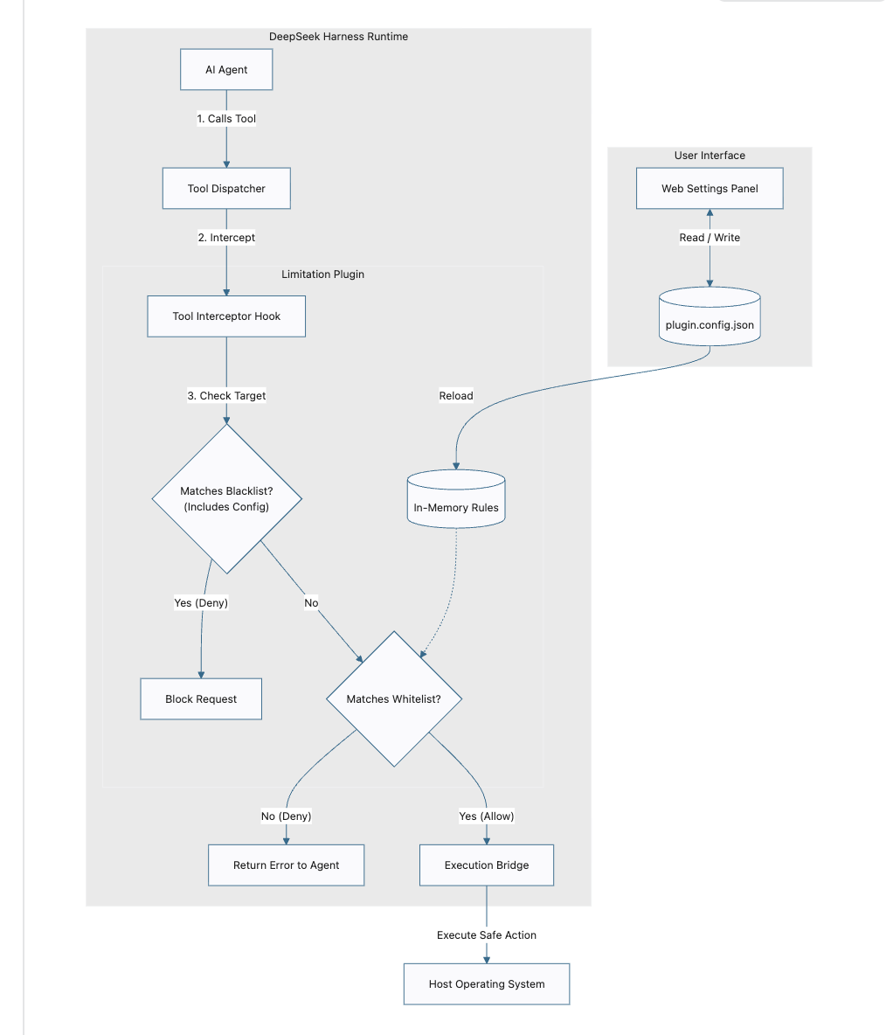
Comment：
5. Major Design Decisions
Decision 1: Dual Control Strategy (Whitelist + Blacklist)
•Choice: Combine a tool whitelist with a target blacklist (protecting plugin.config.json by default).
•Role of Whitelist: Controls what tools and commands the agent can run (blocks dangerous or unapproved commands by default).
•Role of Blacklist: Controls what files the agent cannot touch (blocks sensitive files and prevents the agent from modifying its own rules).
Decision 2: Embedded Web GUI vs. Manual File Editing
•Choice: Provide an embedded Web GUI panel for rule management.
•Why: Avoids manual JSON syntax errors and makes rule configuration easier for users.

